While the temps are still cool, we’ll cover one more cool season garden vegetable you may enjoy your hand at growing. Cabbage can also add interesting texture to a flower garden. Many gardeners with small spaces have begun to add vegetables to their design plan and cabbage is a great one to try.
We have all undoubtedly enjoyed cole slaw at a barbeque or sauerkraut with our favorite German dinners. Cabbage is an inexpensive, versatile, tasty and easy to grow vegetable you can enjoy practically year-round. Cabbage is a cole crop and cool season vegetable that can be grown in most areas of Texas and in most home gardens, if given the right growing conditions. Cabbage is among the easier cole crops to grow, which is great news for Texas gardeners!
Cole crops do best when planted in full sunlight in sandy loam soils with lots of organic matter. Most cole crops need 18 to 24 inches between plants and 36 inches between rows. Cabbage can be grown in both spring and fall, but fall planting often is more successful because spring plantings can be hampered by loopers (worms). Cabbage thrives in moist soil and is ready to be harvested when the head becomes firm. For more information on what varieties of cabbage grow well in Texas, best practices in fertilization and planting methods, visit agrilifeextension.tamu.edu/library/gardening/cole-crops/.
Whether you grow your own cabbage or pick it up from your grocery store, you can enjoy the wide variety of types and uses of the vegetable. Cabbage comes in many colors, including green, red, purple and white. Cabbage can be enjoyed in slaws, in fermented foods like kimchi or sauerkraut, in salads, soups, stir-fry and more! Cabbage is a rich source of vitamin C, calcium, fiber, vitamin K and folate, along with many other vitamins and minerals.
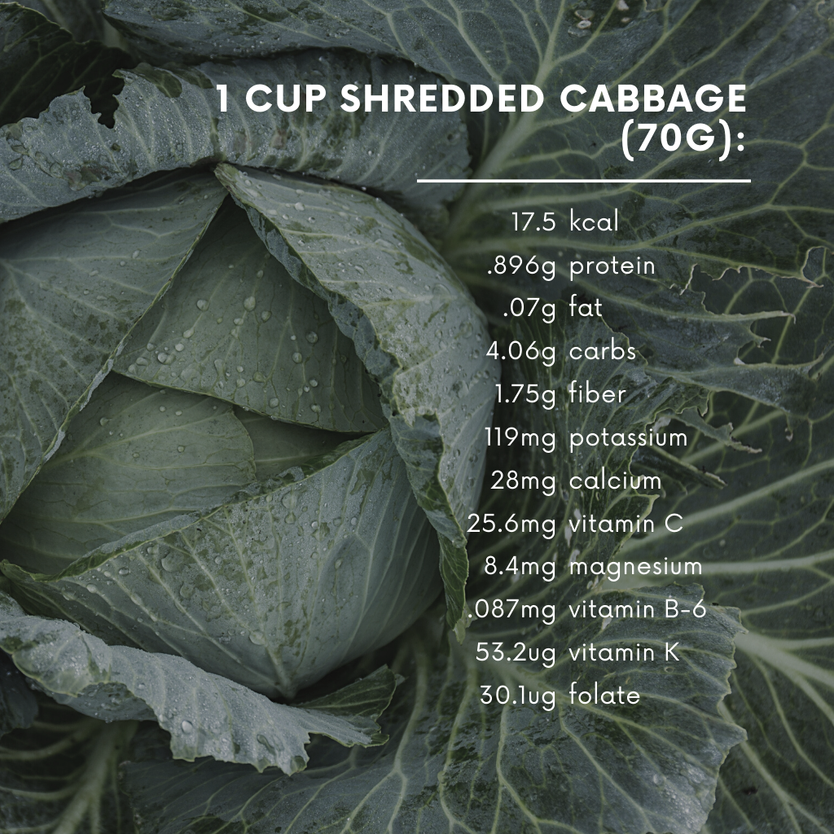

AgriLife Extension’s Dinner Tonight has great recipes using cabbage, like CabbagE Meatballs, Soba Noodle and Snap Pea Salad, Cranberry Apple Coleslaw and Shrimp and Slaw Street Tacos. For more recipes using cabbage and other wholesome ingredients, visit dinnertonight.tamu.edu/.

