Preparing Your Yard for the Winter Months

Awe, the cool air is on the way and your yardwork woes should lessen. Many are breathing a sigh of relief after the hot summer we have had. I hope you find the following tips useful as you prepare your lawn, garden, flower beds, and/or trees for winter.
Irrigation System maintenance:
Many drip and sprinkler systems need to be winterized if they are not deep enough in the soil to prevent freezing. Before the first hard freeze, you will need to disconnect the system from the water source and open all valves that distribute water. Blowing the lines out with an air compressor will ensure the lines are not full and will not freeze. Perennial plants and lawns need some moisture over the winter months. If we do not receive much moisture this winter, you may need to find a warmer afternoon and turn the system back on. Winterization steps will need to be repeated once watering is complete. Soil moisture surprisingly acts as an insulator for your plants. It is always a good idea to be sure plants are well watered as the climate changes to freezing levels to help plants transition into dormancy efficiently.
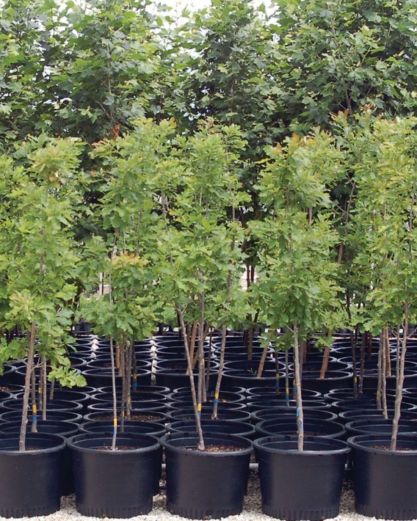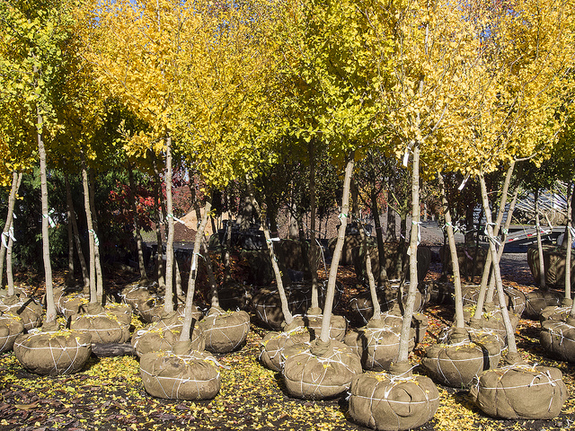
Fig. 1 Fig. 2

Transplanting Trees:
Fall is also a great time to plant or replace a tree. Container potted trees (see fig. 1) always need to be transplanted in the fall or spring. Ball and root trees (see figure 2.) can be transplanted most any time of the year with care. Hot, windy and dry months are not preferable for transplanting any tree.
Fall Lawn care tips:
Fall is a great time to reseed areas of your lawn that may be thin. Lightly till the area in need of reseeding. Spread seed evenly and lightly disturb the soil again to provide cover. Overcasting the area with a light coat of wood shavings or grass clippings is also beneficial to help hold the seed in place and provide moisture retention. Seeds will germinate when the soil temperature rises to the proper level for the variety of grass you have planted.
Did you know some weeds germinate in the fall? Fall and spring are ideal times to apply pre-emergent to your lawn and flower beds to prevent weeds from sprouting. This will help tremendously with weed control in the spring and summer months. This process can be applied to any area you want to control weeds. Just be sure you purchase pre-emergent that is proper for lawn or flower bed areas and do not use pre-emergent if you plan to grow anything from seed the following year in the area where you are applying. Pre-emergent prevents germination of ALL seeds.
Please do not hesitate to contact me if you have any questions about the tips provided.

Megan Eikner – Agriculture and Natural Resources Agent
Texas A&M AgriLife Extension – Potter County
Megan.Eikner@ag.tamu.edu
806-373-0713

