It is difficult to consider landscape plans while the weather continues to cool and shift to winter, but this is actually the best time of year to plan major changes to your landscape. In this three-part series, I will share information that I hope engages you to make the shift to a full or even partial xeriscape area in your landscape. Access to water continues to be an issue for the Texas panhandle and needs to be something we all focus on.

By: Douglas F. Welsh, Extension Horticulturist, William C. Welch, Extension Landscape Horticulturist, and The Texas A&M University System
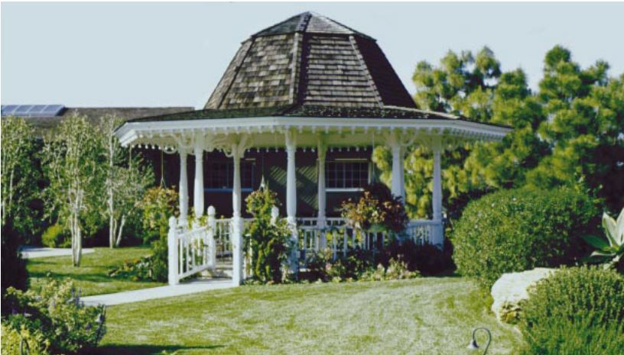

Water has become a critical issue for the future prosperity of Texas. Booming populations have increased the demand on the state’s already limited supply of high-quality water. In addition, seasonal fluctuations in rainfall and periodic droughts create a feast-to-famine cycle in Texas.
In urban areas, about 25 percent of the water supply is used to water landscapes and gardens. In the summer, as much as 60 percent of the water the average household uses may be for landscape maintenance. Many traditional landscapes require large amounts of water, and much of this water is applied inefficiently.
To reduce the excessive use of water for maintaining landscapes, the Texas Agricultural Extension Service encourages Texans to adopt Xeriscape landscaping. This concept conserves water and protects the environment. Xeriscape landscapes need not be cactus and rock gardens. They can be cool, green landscapes full of beautiful plants maintained with water-efficient practices.
The seven water-saving principles of Xeriscape landscaping are not new; they have been practiced in the landscape industry for decades. Combining all seven into a comprehensive program of landscape water conservation is what makes Xeriscape landscaping unique. The principles are:
- Planning and design
- Soil analysis and preparation
- Practical turf areas
- Appropriate plant selection

- Efficient irrigation
- Use of mulches
- Appropriate maintenance
By incorporating these seven principles, you can help preserve our most precious natural resource—water.

Next month, we will discuss: How to create a plan, soil analysis and preparation, practical turf areas, and more.
I also want to share an upcoming event that may be of interest to you. Texas A&M AgriLife will be holding retirement planning workshops on September 26th and October 1st, 3rd, and 8th. If interested, please come by the office to gather additional information and to register. We are located on the Tri-State fairgrounds at 3301 E 10th.
Please do not hesitate to contact me if you have any questions about the tips provided.

Megan Eikner – Agriculture and Natural Resources Agent
Texas A&M AgriLife Extension – Potter County
Megan.Eikner@ag.tamu.edu
806-373-0713

